memo

|  |
| --- |
| Recommendations for Dognition Business Process Change |

|  |  |
| --- | --- |
| To: | Elliot Cohen, Producer at Dognition |
| From: | Matthew Jacobsen |
| Date: | 4 October 2020 |
| Re: | Recommendations to Increase Tests Taken |
|  |  |

Mr. Cohen,

Following on from your request, we have conducted an analysis of the data provided pertaining to Dognition’s business process. In particular, we were requested to investigate possible methods to increase the number of tests that users complete on Dognition’s website. In short, our recommendations are summarized as follows:

1. Broadening the appeal of Dognition’s services and Customer Surveys
2. Implement Reminder Emails
3. Broaden Advertising to Other Countries

# Broadening the appeal of Dognition’s services and Customer Surveys

During our exploration of the data provided, we noticed that Dognition’s appeal appears to be resonating better with owners of pure breed dogs. Figure 1 below shows a comparison of the absolute count and count of distinct breeds with entries in the dataset, after filtering out Dognition’s test data. As can be seen in the top portion of this graph, the total number of pure-breed dogs participating in Dognition’s tests is approximately 3.5 times higher than cross-breed dogs, as well as nearly 2 times for pure-breed dogs than mixed breed dogs. However, we include a distinct count on this, meaning that each breed is counted only one time, we found that there are more individual cross-breed dogs participating than pure-breed dogs. This finding may indicate that, regardless of whatever advertising has been undertaken, Dognition’s services are being viewed more as a method to create a distinction amongst pure-breed owners.

Although this finding is not conclusive in its own right, we feel that Dognition would be well served by attempting more aggressive and diverse advertising towards the general population through venues such as veterinary clinics, pet parks, and animal shelters and stores. Figure 2 also shows that, regardless of breed type, Dognition can expect similar test completion rates. As such, increasing awareness of the brand and decreasing any perceived specialty view of the brand, Dognition is likely to increase user traffic to their website and also increase the number of users taking their tests.

In addition, Figure 2 shows that users show a steep drop-off rate of test completion as users progress through the Empathy related test sequence, followed by a steeper drop-off into the Communication test sequence. In our opinion, this is likely related to the difficulty of the tests. However, we recommend conducting user surveys and focus groups to learn from users what caused them to discontinue testing after this point. This will likely lead to more actionable insights to increase test completion than can be gained from further exploration of this data.

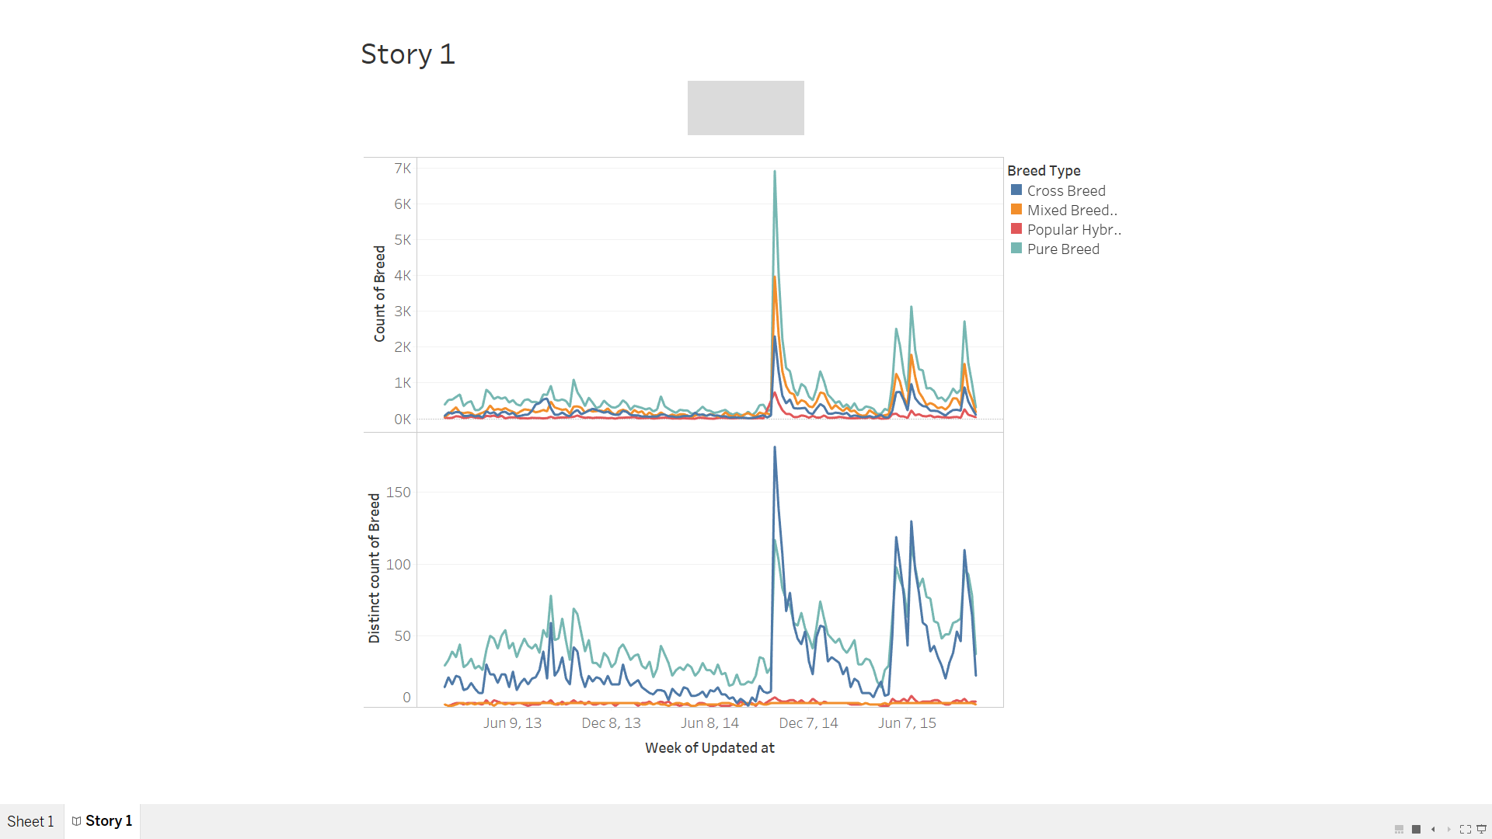

Figure : Count of Breeds and Distinct Breeds over time, by week

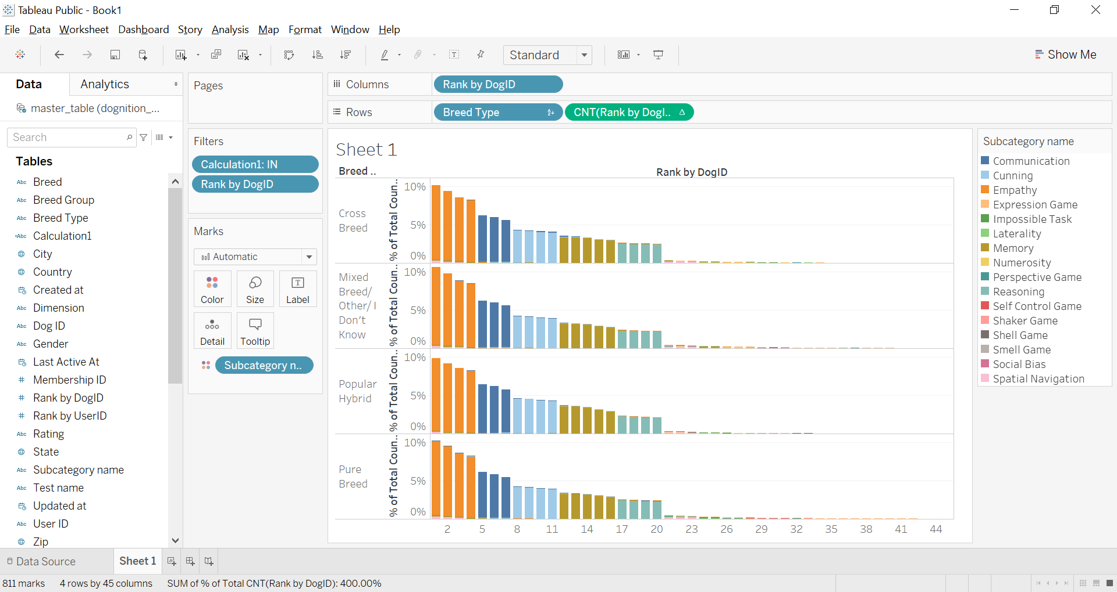

Figure : Percentage of Tests Completed by Breed Type against Order of Tests completed.

**Implement Reminder Emails**

In investigating the number of tests taken, we began by looking at the median time users waited between tests with the total number of tests completed. Figure 1 shows the results of this analysis, which demonstrates that the longer a given user waits to take the next test, the less tests overall they complete.

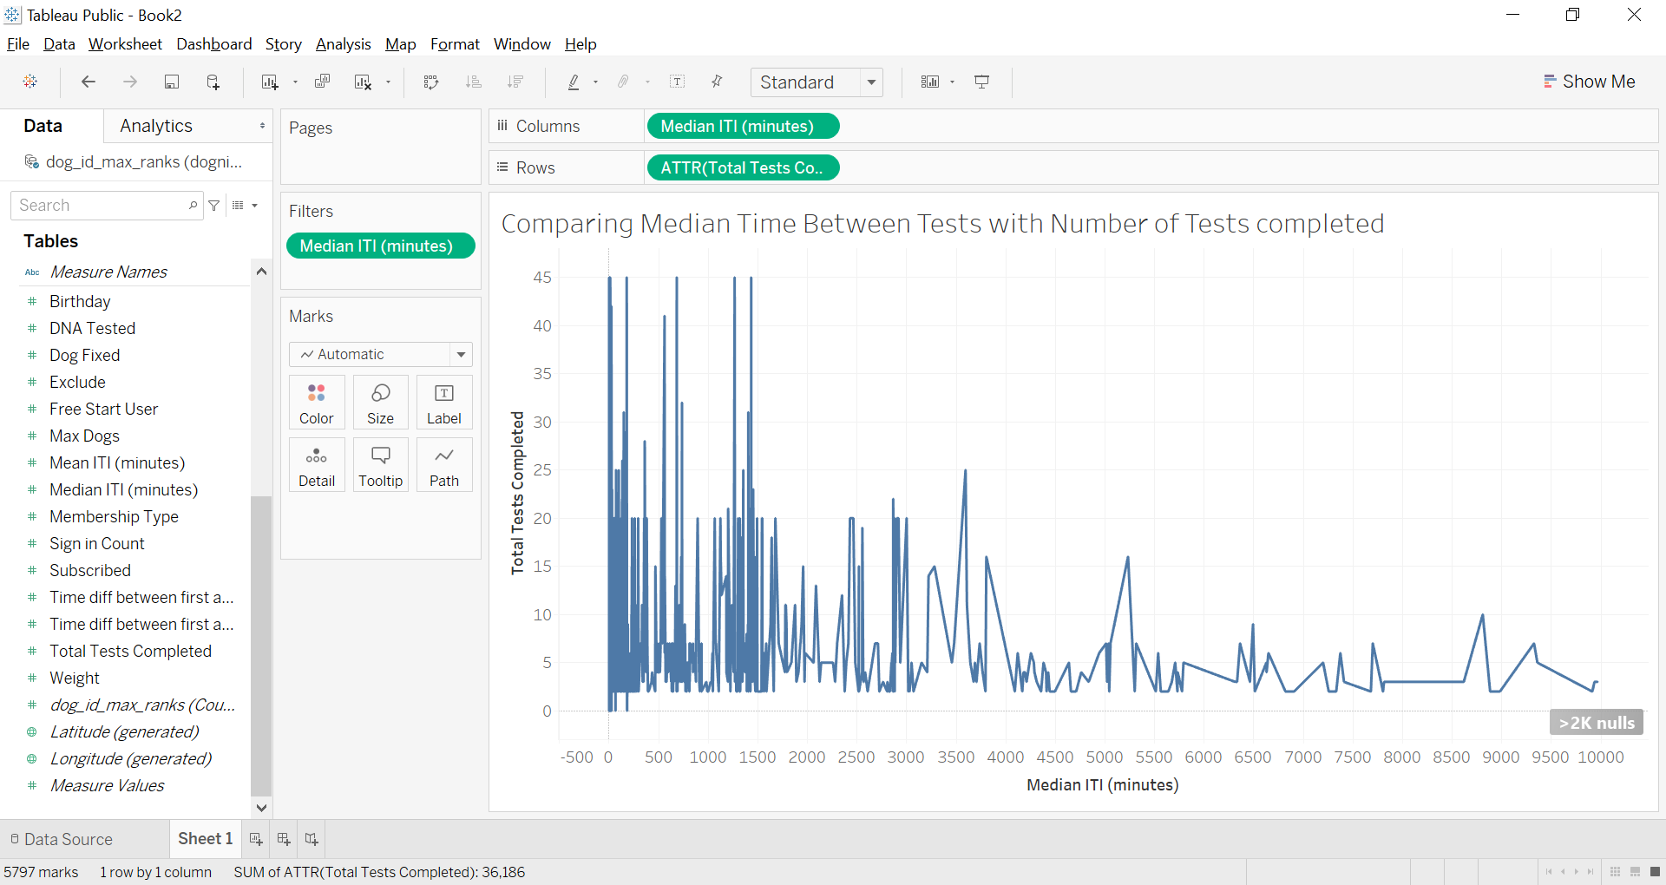

Figure 3: Comparing Median Time Between Tests with Total Number of Tests Completed

Given the correlation between the time between tests and the total number of tests completed, we recommend that Dognition implement reminder emails to encourage users to return and continue. Figure 4 shows the number of tests completed by day of the week. In this, it is obvious that Wednesday, Thursday, and Friday are show the lowest number of completed tests. As such, we recommend reminder that Dognition conduct an A/B test where the A users are not reminded and the B users are reminded on Thursday to return and complete more tests. We are happy to provide further statistical details pertinent to this test, should Dognition choose to accept this proposal. We expect that implementing reminder emails will help to encourage users to return and move the test completion into their weekly routine earlier, instead of the last minute it appears to reoccur to them.

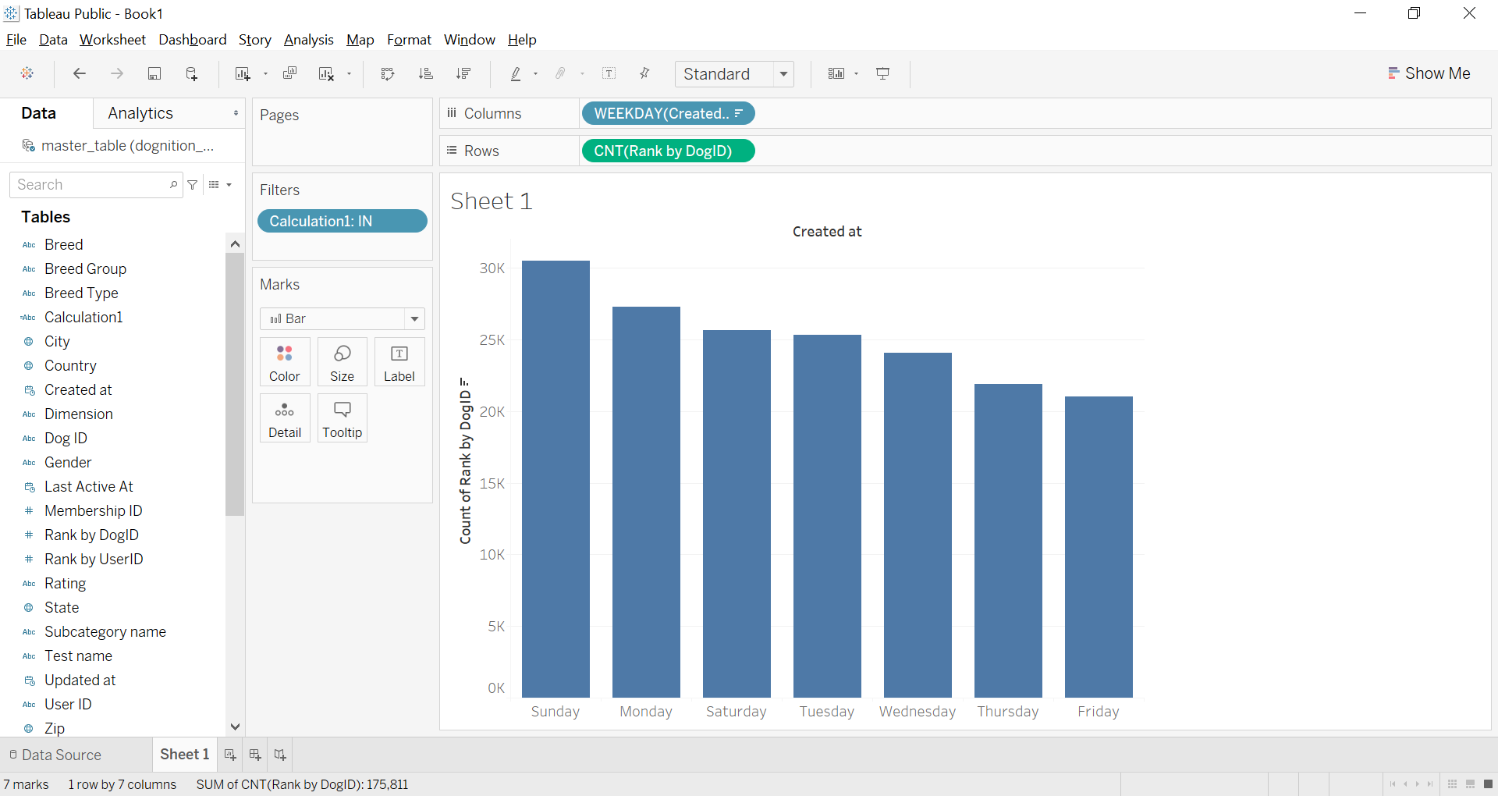

Figure : Count of Tests Completed by Day of Week

**Broaden Advertising to Other Countries**

Our final recommendation for Dognition is to increase overseas advertising. As shown in Figure 3, the United States population (dark blue) consists of the majority of Dognition’s sign-ins, with a total count of over 80,000. However, these users, on average, complete only 11 tests. In contrast, the top three countries in terms of average tests completed contained 117 sign-ins, with a average of 67 tests completed. As such, Dognition has an enormous international potential given the relatively untapped markets overseas.

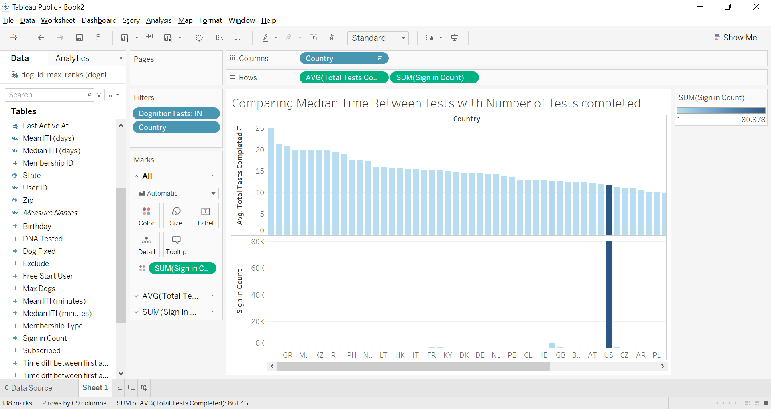

Figure : Comparison of Sign-ins and Average Tests Completed with Country

It has been our pleasure to aid Dognition with this analysis and help to prepare business recommendations to help increase user test completion and business traffic more broadly for your company. If you would like to further discuss any of these recommendations, please feel free to contact us.